Use Case and Design Specification View Query
Project – TEKDESK

Author: Bharath R
Document Number: Use Case and Design Specification View Query V1.0
Document Version Number: Version V1.0 Last Modified: 3rd May 2021

Table of Contents

1. Name 2
1.1 Brief Description 2
1.2 Actor Description 2
1.3 Screen Mockup 2

2 Pre Conditions 3

3. Flow of Events 3
2.1 Basic Flow 3

4. Document Change History 4

Use Case Specification- sample

Name
View Query

Brief Description
This use case describes the scenario after the employee successfully Raises a Query.

Actor Description
Employee who wants to View Query.

Screen Mockup

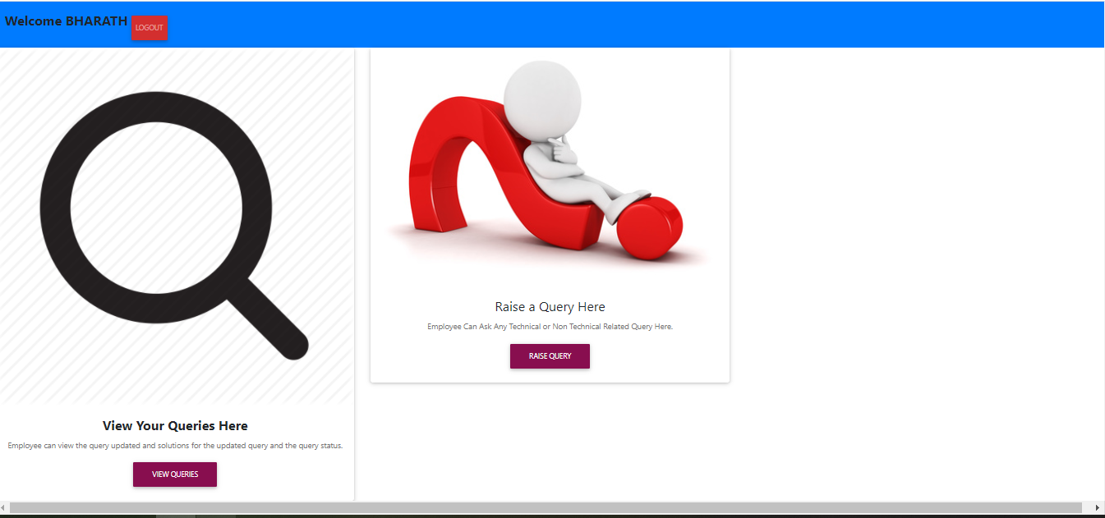

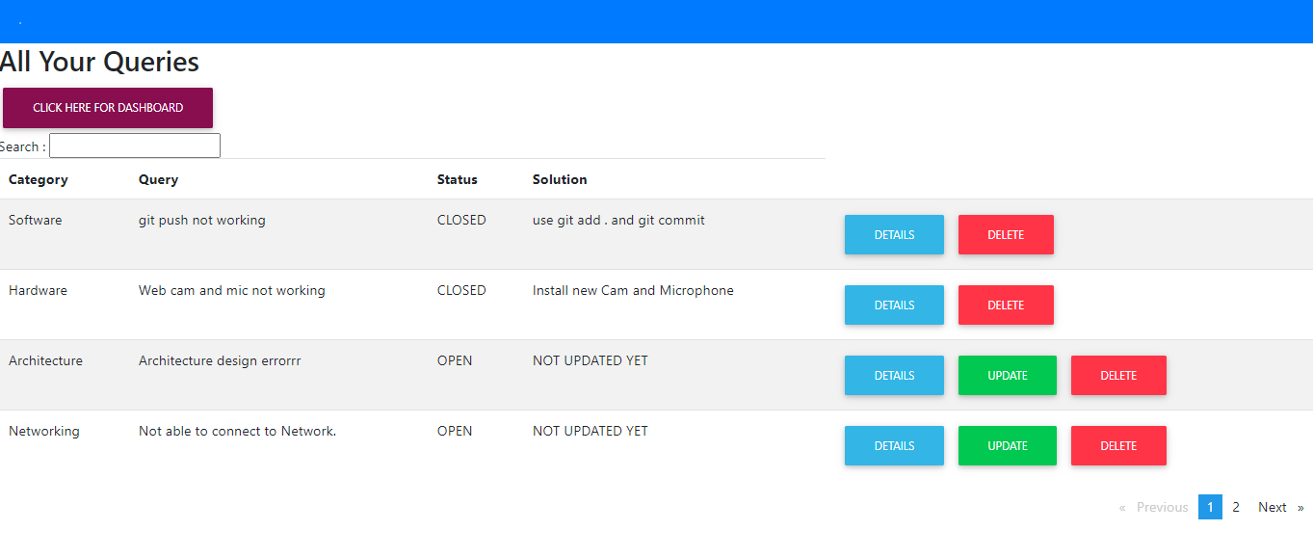

Pre-Condition
Employee who successfully raised query in the previous screen and clicked Go to dashboard .

Flow of Events

Basic Flow

- The use case begins when the employee wants to view his/her raised query.

- . The employee can see View Query button in the Welcome page

- When the employee clicks on View Query button the page navigates to the page where the employees can the View his/her Query raised.

  - View Query page displays four columns Category, Query, Status and Solution .

  - Category column contains the Category of Query selected by employee who raised.

  - Query column contains the text written the employee who raised.

  - If a solution is submitted successfully the Status column display CLOSED else OPEN.

  - Solution column displays the solution given employee’s colleague’s or SME’s or some random employee in the organization.

- Also, queries can be filtered through search box. The search box is a free search box which means the queries can be filtered through by typing Category or Query or Status or even Solution.

- To view complete details of each query, click on Details button, to update the query there is Update button and to delete the query there is Delete button.

Document Change History

Date | Author/Editor | Description of Change(s)
03/05/2021 | Bharath R | Version 1.0

